Term Project: Head Coach Retention Decision & Overall Team Performance Improvements - Valencia C.F

Daniel Arnold, Salva Ribera Palacios, Luis Rosado, Bharath Yadav Golla
University of Tampa
ITM 615: Data Mining
Professor Dr. Kim
December 2, 2024





Table of Contents

Table of Contents 2
Table of Figures 2
Section 1: Executive Summary 3
Section 2: Introduction 4
Section 3: The Business Analytics Problem 7
Section 4: Business Analytics Solution 9
Section 5: Managerial Issues 18
Section 6: Summary & Conclusion 20
References 22

Table of Figures

Figure 1 – Table 1: SPSS Linear Regression Output 12
Figure 2 – Table 2: 2nd SPSS Liner Regression Output 12
Figure 3 – Table 3: SPSS Linear Regression Output 13
Figure 4 – Table 4: SPSS Logistic Regression Output 13
Figure 5 – Table 5: SPSS Logistic Regression Output 13
Figure 6 – Table 6: SPSS Logistic Regression Output ROC Curve 14
Figure 7 – Table 7: Excel Table highlighting sample outcome likelihoods 15
Figure 8 – Table 8: ARIMA model information 16
Figure 9 – Table 9: Trend Line Graph 16
Figure 10 – Table 10: Inputs and Target 17
Figure 11 – Table 11: Coefficients used for building the Predictor equation. 17
Figure 12 – Table 12: 3D Graph showing key factors affecting the match point and color coded to show if the manager was changed in a season 18

Section 1: Executive Summary

Acting as a data analytics consulting firm for Valencia CF, we sought to aid the organization with the decision on the soccer team’s head coach, his performance, and ultimately whether or not he should be retained in this highly impactful position. This decision is a crucial one because waiting too long to move on from this individual can cost the team both time and money while going in a downward trending direction. Ultimately, the team may even be demoted to a lower league if proper action is not taken promptly. The tools we used are different types of data analysis techniques such as a regression analysis and time series analysis. We utilized data about the organization itself but also from other successful teams who have had to make similar decisions on the retention of their head coaches. Ultimately, we strived to provide the organization with actionable predictive and descriptive analysis results to support making the best decisions possible.

A problem we encountered during this project was finding the right data to conduct the analysis on. A data analysis is only as good as the integrity and usability of its data. To emphasize this priority, we spent a lot of time ensuring the quality of the data used, so our main sources of data originated from FBref.com and from Valencia CF itself. The other issues found with the data sources related to how far back we could go (only twenty seasons of history) and not being able to access the coach’s salaries. However, the advantage of just using the past twenty seasons of data is not having any outdated results that are not relevant to the present state of operations change the results of our analysis. While data sources were hard to come by, we also spent a lot of effort on cleaning and formatting the data. This has a huge impact on the quality of the analysis results and required proper attention.

Surprisingly, another issue encountered was the actual results we received from the analysis. While we started this endeavor zeroed in on the head coach and his viability, we received results that took us into a different direction. We started to see patterns that indicated other team improvements needed besides just the head coach and his retainability. We noticed certain improvements could be made that involved player positions such as attackers, midfielders, defenders, and goalies. Thus, the incredible tool of data analytics is brought to the forefront once again! With these results, we have revised and even improved the goals and outcomes we can provide to Valencia CF. We are not only able to provide information about the head coach and his viability but also about the overall team’s performance and what areas of deficiency can be found.

Ultimately, the outputs were quite clear. They indicated team wins, losses, and draws. They showed results such as goals for and goals against. They displayed whether or not the team qualified for the champions league. They helped answer the nuanced question on if the organization should move on from its head coach and provided a lot of information on the organization's overall performance and areas of improvement that should be considered.

Section 2: Introduction

Client Organization Background
For this project, we focused on determining the right time to fire a soccer team's head coach. Each team's situation and environment are unique, with varying expectations and requirements. We analyzed Valencia CF, one of the most renowned soccer teams in Spain and Europe, known for its rich history and success.
Founded in 1919, and located in the Spanish city of Valencia near the Mediterranean coast, Valencia CF actively engages in over 25,000 social initiatives, reflecting its commitment to community development. Since its acquisition by a Singaporean businessman, the club's presence in Asian markets has grown exponentially, leading to new global sponsorship opportunities. Employing approximately 415 staff across various departments the club offers services like broadcasting through VCF Radio and extensive digital media engagement. While primarily focused on the Valencia region, Valencia CF has a significant national and international influence, with 11.5 million social media followers. The club also emphasizes sustainability, achieving 100% renewable energy sourcing and significantly reducing its emissions, positioning itself as a socially responsible organization with a wide-ranging impact.
Understanding Valencia’s background is key in order to perform a correct analysis to when is the appropriate moment to fire a coach and hire a new one. Valencia CF is currently facing significant challenges, particularly concerning its management and relationship with fans. The club has been criticized for a lack of transparency and effective leadership under its president and directors, leading to discontent among supporters. The manager’s performance has also come under scrutiny, with fans expressing frustration over inconsistent results and tactics. Valencia CF was purchased by Singaporean businessman Peter Lim in 2014 for approximately €94 million. At the time of the acquisition, the club had a debt of around €300 million. Currently, the debt situation remains very bad, with estimates placing the club’s debt at approximately €400 million, raising concerns about its financial stability and prospects.
Valencia CF has experienced a notably high turnover of managers in recent years, reflecting ongoing instability within the club. Since the acquisition by Peter Lim in 2014, the club has gone through numerous managerial changes, often resulting from poor performances, conflicts with management, or a lack of alignment with the club's vision.
This frequent turnover has created a sense of uncertainty and inconsistency in the team's performance, as new managers often bring different tactics and philosophies that require time for players to adapt. The club's search for a long-term manager has been complicated by the need to meet fan expectations while balancing financial constraints. This cycle of change has contributed to frustration among supporters, who often feel that the lack of continuity in management difficult the club’s ability to build a competitive team capable of challenging for higher ranked positions in La Liga and European competitions. Historically, Valencia CF has been a strong contender in La Liga, often ranking high in the league standings. However, since the acquisition by the new owner, poor managerial decisions regarding head coaches, club philosophy, and player signings have led to a decline in the team's competitiveness. Currently, in the 2024/2025 season, the club is facing relegation, enduring one of its worst starts in recent history.
As an external consulting firm, we leveraged data analytics and artificial intelligence to address Valencia CF's current challenges. Our approach enables us to provide the club's directors and president with timely insights on the optimal moments to fire a coach and hire a new one. We consider various factors, including team performance metrics, player dynamics, and fan sentiment, to ensure that our recommendations are well-informed and relevant. By implementing this data-driven strategy, we aim to improve the team's league standing and enhance its relationship with fans. If the club can successfully execute these changes in the long term, we anticipate that every financial aspect will see improvement, paving the way for expansion into new markets and greater customer retention.
Current Status and Analysis
Valencia FC’s President Lay Hoon Chan stated that the Group believes in and invests in digital transformation and the use of data for decision-making that generates more value for fans (Valencia article) . Data has played a fundamental role in the work processes of the companies that make up the Group: from commercial analysis to sports analysis. Among other things, the data is already being used to analyze player performance, determine ticket prices, and/or improve the visitor experience of its physical and online stores. In addition, future projects such as data-driven marketing automation and the digital renaissance of the Club's membership program are in the works.

To enhance their analytical capabilities, Valencia FC has partnered with a third-party analytics company, Blinkfire Analytics, to better leverage data insights. Culturally, the Valencia CF Group is adapting to data-driven decision-making (sporting and non-sporting). Every contact with any stakeholders, fans, and customers enriches the dataset and improves the decision-making process.

Use of MS Excel
Although Microsoft Excel is typically viewed as a basic reporting tool, Valencia CF is likely utilizing it for simple data analysis. However, the club is also advancing its analytics strategy, indicating a shift toward more sophisticated data practices.

Data Warehouses
While specific information on data warehousing is not available, many organizations such as BlinkFire Analytics, at this level typically employ data storage solutions to integrate data from various sources, suggesting they may utilize some form of data warehousing.

Integrated Information Systems (ERP)
Regarding integrated information systems, there is no explicit information on whether Valencia employs an ERP system; however, many clubs implement integrated systems to manage functions such as ticketing, merchandising, and finance.

Business Analytics Team & Tools
Additionally, there is no specific indication of a dedicated business analytics team; however, the club has partnered with a third-party analytics company for social media and sponsorship metrics, reflecting the use of specialized tools for analytics. Furthermore, they have collaborated with the company Zeus for data analysis, enhancing their analytical capabilities. Furthermore, the reliance on external tools suggests that Valencia may not have developed a comprehensive in-house analytics system.

DELTA Analysis

 | Current Status | Maturity Level
Data | Basic reporting using Excel; potential data warehousing | Basic, Emerging  (Stage1)
Enterprise | Potential use of integrated information systems (ERP) | Moderate  (Stage 2)
Leadership | Ambitions for data-driven decision-making but no specific analytics team mentioned | Partnering with professionals  (Stage 4)
Targets | Use of Blinkfire Analytics for social media metrics and Player performance | Precise  (Stage 5)
Analysis | Potential use of high-end analytical tools by BlinkFire and Zeus | Unknown, potentially good  (Stage 4)

Based on the information available, Valencia CF's analytical maturity appears to be in the Diagnostic Analytics stage with aspirations for Predictive Analytics. They are leveraging external tools for specific analytics needs, and while they may not have a full-fledged in-house analytics department, there is evidence of a cultural shift towards data-driven decision-making.

Section 3: The Business Analytics Problem

Current Business Processes
When it comes to the current business process, there is a complex approach taken by ownership that combines both qualitative and statistical data regarding the coach. The intangibles about the coach need to be prevalent. These include his ability to lead and inspire players, create a motivational environment. This indicated in an article on the team’s website where it states “Rubén Baraja is now in his new role as a coach of Valencia CF. The former player and club legend showed his conviction that with hard work, determination, character and personality, the coaching staff and the players will be able to overcome the current difficult situation in the LaLiga standings” (Valencia CF, 2023).

Issues with the Current Business Processes
The main issue that Valencia CF is facing is that they ended the season 8, 6 and 5, finishing in 9th place and they did not qualify for any European soccer tournament i.e. Europa league or Champions League. They would like to get back to achieving a spot in European soccer, as they did in 2006-2007, and winning the league as they did back in the in the early 2000’s. When the club does not win, they do not receive more advertising money and bonuses from the league, thus they cannot grow. In analyzing a football club’s success there are many factors that play a part in how they will perform and what they can achieve. Of these many factors we are focusing on the person who is usually blamed or praised when the club is in decline or achieves greatness, the Manager. The current manager, Ruben Baraja, has been with the team since February of 2023. Is this enough time for a manager’s campaign to make a difference? Are there other factors that influence success that are out of the manager’s control? These are all questions we aim to answer through our study.

Improvement Opportunities for the Current Business Process
There are possibilities to improve the current business process at Valencia CF. Our approach is simple. In using data from previous 20 seasons at Valencia as well as referencing other football teams, we will utilize several data mining techniques, discussed in more detail below, in various types of analytics namely descriptive, predictive and prescriptive to achieve the goal of advising the Valencia football club namely, President Lay Hoon, Owner Peter Lim and Valencia’s board insight to decide if they should or should not allow, Ruben Baraja, the current manager to remain in his position. Along with this we aim to translate the data into useful and relevant format. This will allow us to give the members of Valencia an opportunity to decide how to build a roadmap to success for the future of the club.

Problems Solved using Business Analytics
The most urgent problem we will look to solve is first to improve the quality of analysis and second to increase the speed at which the team’s ownership knows for certain that it is time to move on from a coach. We look to improve upon the current business processes through our referrals and recommendations. While it can be uncomfortable to fire a coach and possibly pay an individual for years after they’ve left due to contract length, the alternative is even worse. If too much time is taken to make this decision, the team will veer further downward and have long term effects, such as losing talent, loss of profit from fans unwilling to support a losing team, and even possible demotion to a lower football league.

Data Sources
The sources of data we will look to use are from reputable websites such as transfer market, FBREF, LALIGA, LaSource and Wyascout. We are still in the research phase will undergo meticulous analysis of these sources to ensure they are compatible with our intended processes.

Dataset Structure
The variables we are looking into are the following: match results, penalties, goals, cards, assists, point in the season manager began, matches played, player requests for trade, points for, and points against. Ultimately the flag variables will need to be things like when does the coach leave the team and when does the team win a championship, have a winning record, or receives other major achievements. Additionally, we will be conducting a trend analysis, because even if a team is not performing well, if it having continual improvement, that is valuable information for ownership to have. As far as the size of the dataset, we will be looking at forty years of performance. This gives a broad and objective overview of not just the current acting coach, but of his predecessors. Lastly, we will be looking to collect data from other comparable football clubs; not just Valencia. This will aid in comparing the team to other successful clubs, and seeing how they managed coach releases. We can filter through to only the most successful clubs, and use this information to make valuable recommendations.

Possible Data Mining Techniques
The data mining technique that can be used for this analysis are the following: logistic regression analysis, decision tree analysis, time-series analysis, and cluster analysis. We can use the regression analysis to identify relationships between various match variables (e.g., goals, assists, penalties) and team success metrics like wins, points, or championships. The regression model can determine which performance metrics have the strongest impact on overall team success and whether the coach’s influence significantly affects those variables.

The Time Series analysis can be implemented to analyze the team's performance over time to detect trends, cycles, or anomalies. This technique can help forecast future team rankings based on historical patterns. Additionally, this analysis can be extended to predict the ranking pattern into the future, aiding in strategic decisions such as whether the coach should be retained or replaced based on long-term performance trends.

Multiple linear regression can be used to analyze relevant performance metrics and their impact on team performance. Additionally, it can be used to frame a regression equation to predict future instances, serving as a data-driven method to evaluate the team's trajectory and assisting in critical decisions such as whether to retain or replace the manager.

Section 4: The Business Analytics Solution

We began our analysis by using Linear Regression to identify KPIs (Key Performance Indicators) that significantly impacted the team’s overall performance. By analyzing historical match data dating back 20 seasons we pinpointed variables such as points per match, goal differential and goals against and percent possession in order to quantify the relationship between these variables and the team’s overall performance providing actionable insights to produce targeted improvements.

We utilized Logistic Regression to produce predictable insights around recommendations for aiding in the decision whether or not to keep Ruben Baraja as manager. This binary classification model helps us understand probability of different outcomes given specific conditions.

We used Time Series analysis to identify patterns in the team’s performance over the years, with the target variable being k, which represents the team’s ranking (where higher values of k indicate poorer performance). This approach allowed us to track how the team's ranking evolved over time and analyze trends, cycles, or anomalies in performance. While ranking is technically an ordinal variable, research has suggested that when the number of ranks or categories is sufficiently large, rankings can often be treated as continuous variables for analytical purposes (Perspective Article, 2020). Furthermore, we extended this analysis to predict the ranking pattern up to 10 years into the future, providing insights into the long-term trajectory of the team’s performance.

In the final step, we applied a reverse-engineering approach by using team ranking as the target variable in a multiple linear regression model. This equation was designed to predict rankings for ongoing and future seasons based on relevant performance metrics. Additionally, we created an Excel-based Predictor tool, where variable values can be entered to calculate the expected rank. It can be used as a data-driven method to evaluate the team's trajectory, assisting in critical decisions such as whether to retain or replace the manager.

Through the combined use of these analytical methods we have provided Valencia CF with a comprehensive understanding of their performance dynamics and decisions for the club’s future.

- Rank (k): The rank of the team at the end of the season which if 6 or above qualifies a team for European cups such as Champions League or Europa League.
- Matches played (MP): The total number of matches per season that the manager has coached the team. This reflects the tenure in a managerial position.
- Wins (W): The total number of Wins achieved by a coach and team in a season
- Draw (D): The total number of Draws or Tie achieved by a coach and team in a season
- Losses (L): The total number of Losses suffered by a coach and team in a season
- Goals For (GF): This indicates the total number of goals within a season scored by the team. This measure can often highlight attacker talent, attacking tactics or the lack there of.
- Goals Against (GA): This indicates the total number of goals within a season scored against or on the team often indicating poor defensive players or tactics.
- Goal Difference (GD): The goal difference is calculated by simply subtracting the Goals For – Goals Against = Goal Difference. This is an overall measure that reflects the team’s performance as a whole in terms of both defensive strength and attacking success.
- Points per season (Pts): This is the total number of points earned that are a direct result of the number of Wins, Draws or Losses in a season. Each result has a different value which is calculated after each game. i.e Wins = 3pts, Draw = 1pt and Loss = 0pts. This measure is directly correlated to the ranking throughout the season as at the end of the season. The team with the most points finishes top the league and lowest at the bottom in which they would get relegated or demoted to the league below. This is ultimately the biggest failure a team can experience
- Points per Matches Played (Pts/MP): This is one of the most analyzed statistics in football/soccer. This reveals the average number of points earned by a team per match. This is calculated by dividing the total number of points earned (Pts) in a season by the total of matches played (MP).
- Manager Change: This outcome variable was developed by our team in order to identify seasons when a managerial change was made. This is defined as a dismissed or left and a new manager was appointed. It is worth noting that it is understood that these changes were not always 100% a result of performance within the club. There are interim coaches as well which come in as coaches and not full managers as the leadership team decide on a new manager.

Logistic Regression

Defining and Building a Binary Target Variable
The role of a manager is a very nuanced and multi-faceted role. It demands focus, determination and tireless work far beyond the 110 x 74-meter pitch. It is a leadership role that requires sharpness and adaptability to make decisions that will affect the organization in each game. It also requires the ability to mold the identity of the team through a performance enhancing culture. We will be focusing on the qualitative factors in this analysis. The focal key performance indicator is Points per Matches Played (Pts/MP). This is the metric gives us a good benchmark to gauge the outcome of a season and help us in tying this result with our recommendation to continue with the current manager or not.

It is worth noting that there are many skills outside of the tactical ability of a manager that plays a part in their role. We will be addressing the “soft” skills and factors as well that fall outside of the statistical analysis.

Reasons why Points per Matches Played is a vital performance metric:
- Diversly Applicable Metric: Pts/MP is a metric widely used across European leagues. It provides a standard by which to measure a team’s success that is comparable across leagues. Also allowing us to compare past performances and potential successes.
- Overall Performance: Pts/MP accounts for all games through points earned via Wins, Draws and Losses throughout the season.
- Success Measure: Pts/MP is a direct measure to a manager’s success with a team within a given season.
- Predictive Performance: Pts/MP is indicative of a manager’s success and the likelihood of success in the future should they continue as manager. This aspect of this variable be weighed heavily in our analysis.

As we built our Logistic Regression model, we identified Points per Matches Played (Pts/MP) as the focal metric. The goal is to use this as a metric to gauge success in a season and as a club compared to current outcomes with the manager that is in place. This will give us data to help in recommending a decision to the Valencia CF leadership team.

As an additional metric clear we developed a threshold of between 1.505 and 1.695 as the range of Pts/MP based on winning and overall season Pts/MP averages in the past 36 seasons. Lower than 1.505 would indicate that the the current manager should be up for review. We defined a winning season as finishing within the top 6 spots in ranking. We then took an average of all these seasons we were able to create our peak performance threshold to enable us to utilize in making our recommendations depending on where the current coach has performed. From this benchmark we can create a binary analysis based on the outcomes to be classified as the manager will continue or not.

The logistic regression model developed aims to give us data points that will allow for a recommendation to act. With the available dataset we can recommend whether the current manager, Ruben Baraja, should remain or be put under further review. This will give leadership more in-depth defensibility and reasoning behind their decision.

Addressing Multicollinearity

In our initial Linear Regression model we experienced Multicollinearity, this is an issue that arises when independent variables are highly correlated thus leading to inflated standard error and undesirable parameters. By filtering out these variables through a multistep process we can only use variables that will produce our desired outcome.

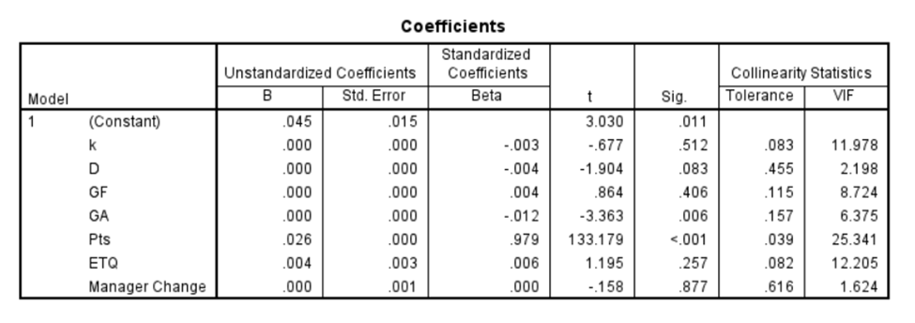
Table 1: SPSS Linear Regression Output

Seen in the Table 1 the coefficients in the model with a VIF score of >10 was excluded from the model as this was evidence of multicollinearity. Among the variables excluded were Goals Against (GA), Points per Season (Pts), Rank (k) .This would indicate that the variance of the coefficients for a particular independent variable are inflated by a factor of 10 as it corelates with other variables in the model.

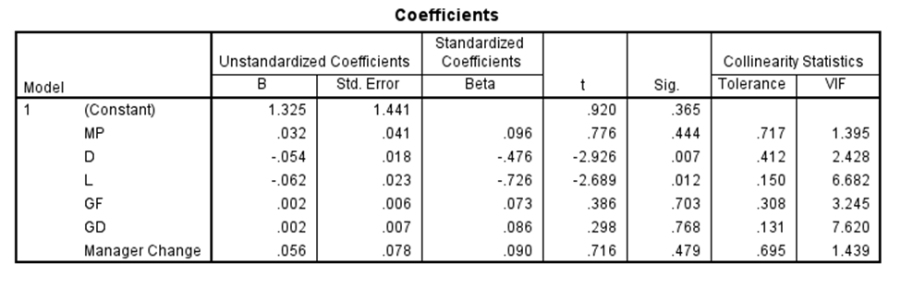
Table 2: 2nd SPSS Liner Regression Output

In Table 2 we see that there was still one remaining factor with an undesirable VIF factor >10 and needed to be excluded. This was done in order to mitigate the effects of multicollinearity and produce a much richer and ultimately more accurate model result that will ultimately influence our overall recommendation for a managerial change.

Addressing Statistical Significance

Along with the VIF score showing multicollinearity the factors listed in the above section that were removed also showed low t-values and high p-values. This indicates a lack of statistical significance within the model as a predictor to the dependent variable of points per matches played.
Removing these variables allowed us to simplify the model and ultimately improve the model’s accuracy. This all in an aim to produce affective insights and recommendations.
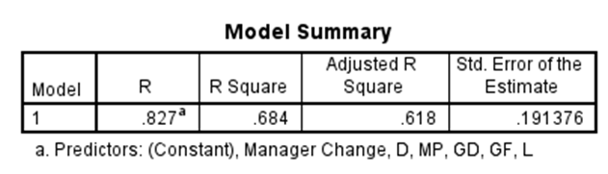
Table 3: SPSS Linear Regression Output

As an additional note the table above showcases that our R Squared value did not change significantly meaning that the remaining variables in the model can explain 68.4% of variance in the model. This gives us confidence in the accuracy and ability of this model to give evidence of recommended actions.

Interpretating Results of Logistic Regression

Once we established the variables that will produce a reliable model to produce meaningful and actionable insights to influence recommendations of managerial change.
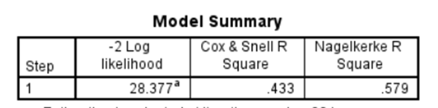
Table 4: SPSS Logistic Regression Output

In interpreting the Logistic Regression, we used the Nagelkerke R squared value. This value indicates that the combination of selected predictor variables will collectively account for 57.9% of the variability observed in the binary outcome variable. This further supports our decision to utilize the managerial changes decision through this model outcome.

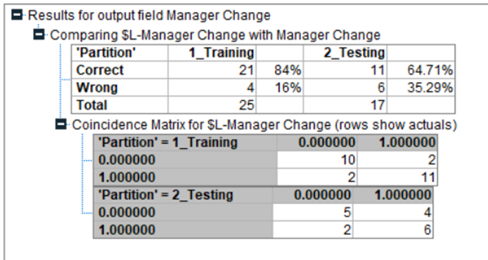
Table 5: SPSS Logistic Regression Output

In addition to the Nagelkerke R squared value, we created a confusion matrix to provide a detailed breakdown of the model’s predictions compared to the actual outcomes. From the confusion matrix several outcomes were calculated including accuracy, sensitivity and Type II error or specificity.

- Accuracy: This metric provides a general overview of how the model performs in predicting if there should be a managerial change but it will not provide the complete picture. The accuracy of the Testing data set was a bit lower than the training data set which was 64.71% which indicates that the model does not generalize well to data outside of this dataset but is not cause for concern.
- Sensitivity: This identifies the actual positives that are correctly identified by the model. It indicates the model’s ability to correctly detect if a managerial change is necessary. This measure was calculated at 75% in the Testing data and calculated at 84.6% in the Training data.

ROC Curve
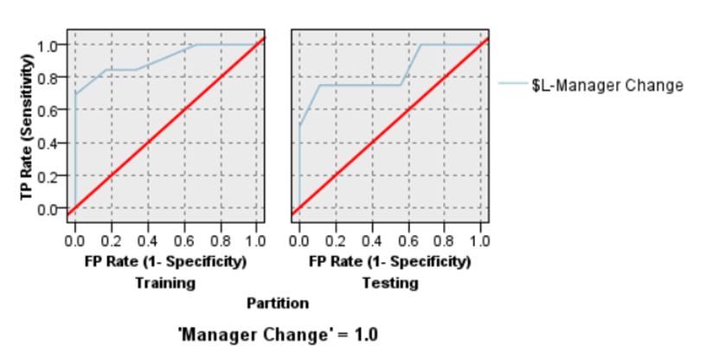
Table 6: SPSS Logistic Regression Output ROC Curve

The ROC graph is a measure by which we compare the Training dataset to the Testing dataset. This suggests that the logistic regression model generalized well with data not in the dataset. The fact that the Training dataset shows higher AUC is favorable and also tells us we are in the clear for overfitting. This means slightly low generalization but not horrible. It will be ideal to continue monitoring performance.

Output Table from Logistic Regression

 | Pts/MP | $L-Manager Change | $LP-Manager Change | $LP-0 | $LP-1
2022-23 | 1.29 | 1 | 0.708 | 0.292 | 0.708
2018-19 | 1.61 | 1 | 0.839 | 0.161 | 0.839
2011-12 | 1.61 | 1 | 0.751 | 0.249 | 0.751
2008-09 | 1.87 | 0 | 0.657 | 0.657 | 0.343
2004-05 | 1.82 | 0 | 0.648 | 0.648 | 0.352
2000-01 | 1.58 | 0 | 0.833 | 0.833 | 0.167
1993-94 | 1.45 | 0 | 0.84 | 0.16 | 0.84
Table 7: Excel Table highlighting sample outcome likelihoods

We can see that from a sample of seasons throughout the last 35 years the higher the points per matches played (Pts/MP) the lower the likelihood of there to be a managerial change. For example in 2008-09 the Pts/MP was 1.87 and the coach remained appointed. The above years were highlight in order to explain that with our analysis there is no gaurantee and even at times when the Pts/MP was low, see 2000-01, ownership decided not to make a managerial change. To reiterate our analysis is to verify trends and likelihoods and there are many factors at play that may be subject to review in order to make the final decsion.

Time Series Analysis

Use of Ranking as target variable
The ranking was chosen as the target variable because it directly reflects the team's overall performance in a measurable way. Team rankings provide a clear, quantifiable outcome that encapsulates various performance factors such as match results, goals scored, and defensive stability. While ranking is technically an ordinal variable, research suggests that when the number of ranks or categories is sufficiently large, rankings can often be treated as continuous variables for analytical purposes (Perspective Article, 2020). Additionally, this analysis has been extended to predict the ranking pattern into the future.

After evaluating various time series models, the ARIMA model was identified as the most suitable for the analysis. It provided the highest R-squared value and offered the best trendline fit for the data. The ARIMA model effectively captured the underlying patterns and fluctuations in the team's performance, making it the most reliable method for forecasting future rankings based on historical data. This model's accuracy in predicting the team’s trajectory serves as a valuable tool in making informed strategic decisions, particularly in evaluating coaching effectiveness and team performance over time.

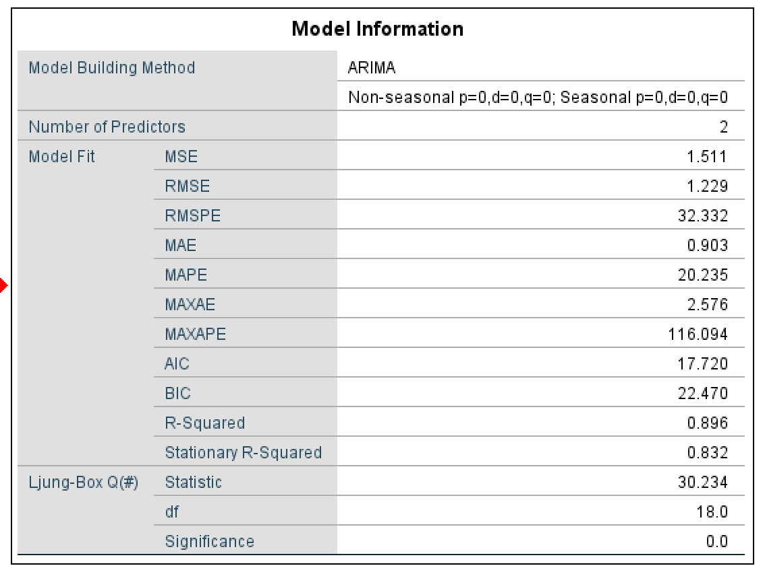
Table 8: ARIMA model information

The trendline generated by the ARIMA model was further extended into the future for a period of 10 years, providing a long-term projection of the team's trajectory. This forecast serves as a valuable tool in making informed strategic decisions, particularly in evaluating coaching effectiveness and team performance over time.

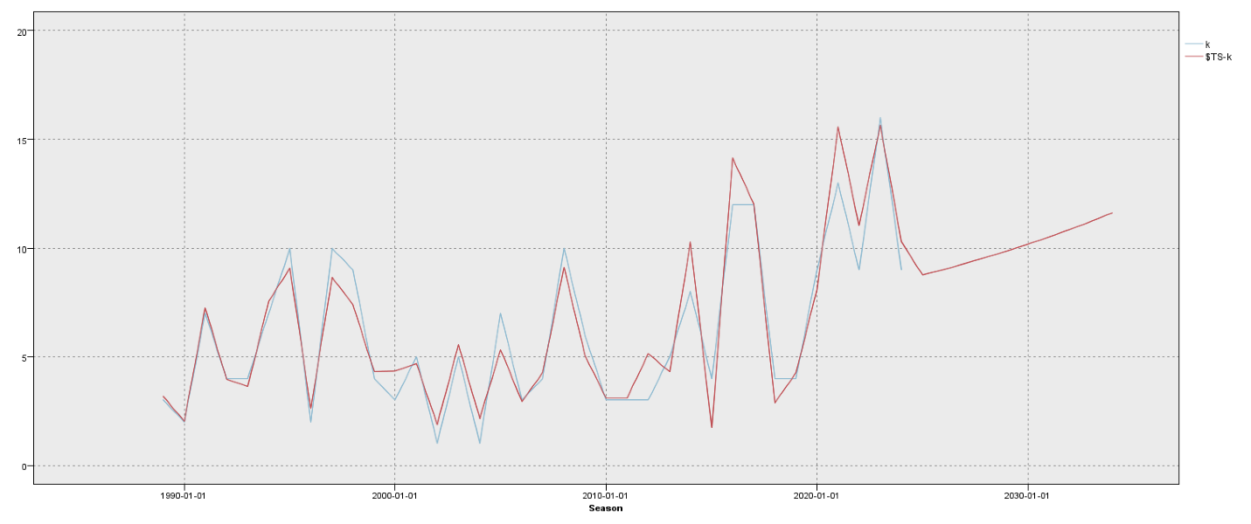Table 9: Trend Line Graph

Multiple Linear Regression

Multiple linear regression was chosen for this analysis to explore the relationship between team ranking and key performance metrics. This method was selected due to its ability to quantify the impact of multiple variables on the team’s overall ranking. By incorporating various performance indicators—such as goals scored, possession rates, and defensive statistics—the model offers a detailed view of how these factors collectively influence the team's position in the rankings. The regression equation generated through this approach allows for predictions of future rankings, providing a valuable tool for data-driven decision-making in evaluating the team's performance and determining strategic actions, such as whether to retain or replace the coach.

We utilized several input variables to model the team's performance, including ranking, matches played, wins, draws, losses, goals for, goals against, goal difference, points, and manager changes. These variables were selected as they represent key aspects of the team's overall performance. The dependent variable in the model was the team's rank, which was used to assess the relationship between the input variables and the team's performance. This approach allowed for a comprehensive analysis of how each factor influences the team's ranking and facilitated predictions of future outcomes.

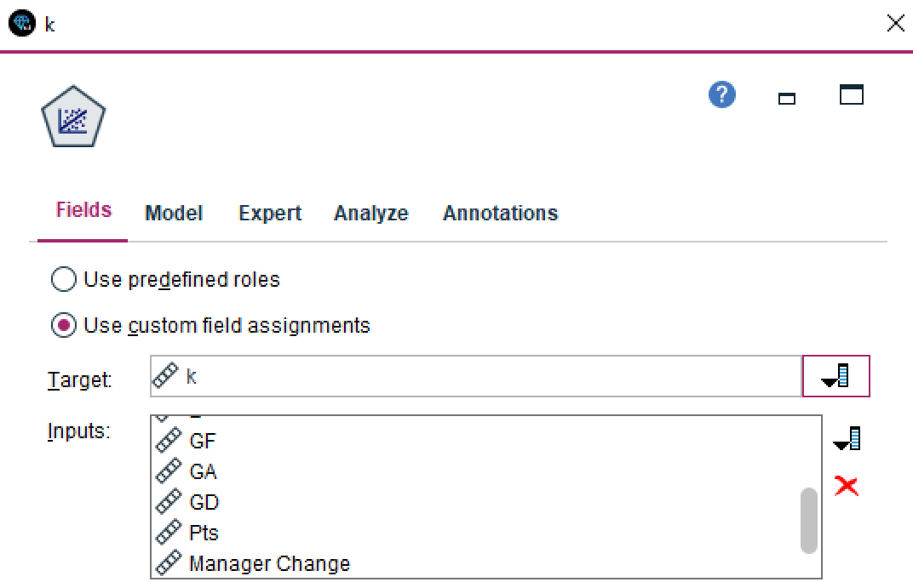
Table 10: Inputs and Target.

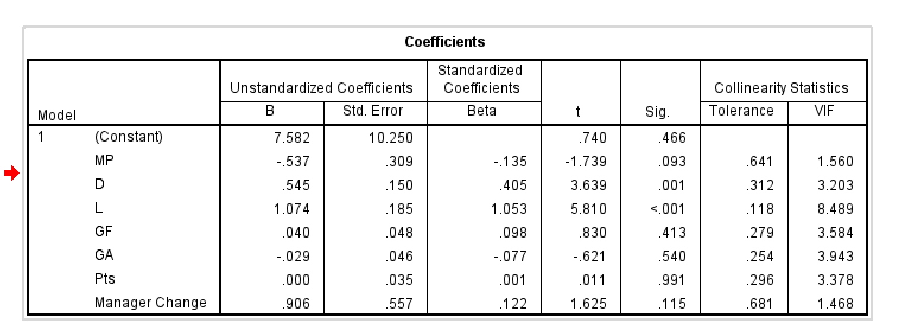Table 11: Coefficients used for building the Predictor equation.

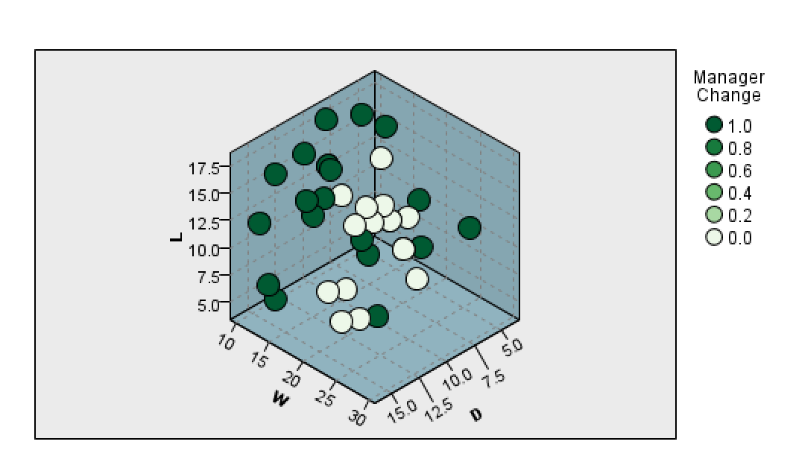
Table 12: 3D Graph showing key factors affecting the match point and color coded to show if the manager was changed in a season.

Section 5: Managerial Issues

To help Valencia C.F. decide whether to keep the head coach and improve overall team performance at Valencia C.F. a business analytics solution needs to be carefully planned. The success of this initiative depends on setting clear objectives, to establish an effective communication, teamwork among everyone involved, and an effective integration of analytical tools into the team decision making processes.

A key focus for management at Valencia C.F. is to set clear and measurable goals for the project. These objectives should guide the analysis and support the club's main priorities, like improving team performance and achieving long-term success. It's important to share these goals openly with everyone involved, at this moment where management is being assessed constantly by every stakeholder, transparency is vital in each step of the decision-making process. This includes players, staff, and fans, to build trust and teamwork. Defining key qualities for the head coach, like adaptability, leadership, and tactical skills, will help in making better decisions.

Recent history has highlighted big cultural and leadership problems at Valencia, especially in how the coaching staff and club ownership work together in their relationship to achieve team success. A clear example is the firing of Marcelino García Toral, who led Valencia to victory in the Copa del Rey in 2019. Despite his success, disagreements with the owner Peter Lim about strategy and signing of new players led to his dismissal as head coach of Valencia C.F. This upset fans and hurt trust among everyone involved in the team, as fans had the feeling that ownership was not worried on winning but only wanted to trade players for self-enrichment, not caring at all of the long term future and teams' success.

While quantitative analysis provides valuable insights into performance, intangible factors like a coach's leadership style, ability to handle pressure, and fit with the club’s values are just as crucial. Listening to fans and staff through surveys or feedback is essential to complement quantitative findings and avoid repeating past mistakes, it is crucial to balance data with people’s opinions.

The tense relationship between Valencia’s management and its fans highlights the need to consider community sentiment and opinions. Fans have often criticized decisions that prioritize ownership interests over team performance. To make the analytics solution more acceptable, the club needs to show a balanced approach that uses both data insights and evaluations of leadership qualities. Interacting with fans and emphasizing the reasoning behind strategic decisions can help rebuild trust and improve the club’s bond with its supporters.

From a technical perspective, Valencia needs to ensure the accuracy, quality and consistency of its data to get useful insights. The club should invest in strong data collection and management systems that are capable of managing historical match data and performance stats. Adding advanced analytical tools, like linear regression and cluster analysis, with existing systems may require updates to the club’s IT infrastructure. It’s also important to train staff to use these tools to encourage a more data focused mindset. For example, teaching management and coaching staff on how cluster analysis identifies and highlights performance by position metrics or how logistic regression predicts coach success can make analytics easier to understand and adopt.

Introducing the analytics solution should happen step by step to avoid interfering with daily activities and operations like training sessions and match preparation. The first steps include setting clear performance metrics and training staff, followed by data collection and validation. After testing and confirming the models, the results can be integrated into decision making processes. Successful implementation will require strong teamwork between data scientists, IT professionals, business leaders, and other stakeholders who will have a key role in ensuring the successful implementation of the solution.

While data models can provide helpful predictions, they must be complemented by qualitative insights. For example, logistic regression may estimate the likelihood of Ruben Baraja’s success as head coach, but other factors like his ability to motivate players, build team spirit, and meet the expectations of ownership must also influence the decision. Valencia should learn from past experiences by promoting leadership stability and by making sure that management and ownership share a common vision of the present and of the near future. This balanced approach, combining quantitative and qualitative insights, will ensure that decisions reflect both the strategic and cultural needs of the club. Combining data-driven insights with a thoughtful evaluation of leadership and community feedback will help meet the teams' objectives, restore Valencia’s competitiveness and improve the relationship between fans, players, and management.

Section 6: Summary and Conclusion

As a data analytics consulting firm, we utilized advanced analytics methodologies to assist in evaluating the performance of the head coach and identifying actionable insights for broader team improvement. Our approach involved leveraging historical performance data and applying data mining techniques, including linear regression, logistic regression, and time series analysis, to provide a comprehensive analysis of its managerial and team dynamics.

Our findings illuminated critical performance metrics such as points per match, goal differential, and points per season statistics, which revealed areas of strength and deficiency. Notably, our logistic regression model indicated a clear threshold for managerial review based on points per match played, providing a robust framework for decision-making. The cluster analysis identified positional inefficiencies, suggesting improvements in player development and tactical deployment, mainly in defensive strategies and midfield control.

Additionally, we conducted a trend analysis to understand performance fluctuations over the past 35 seasons. This revealed the impact of managerial changes and systemic issues affecting team cohesion and consistency. Our analysis underscored the need for stability in leadership and alignment between ownership, coaching, and player strategies.

Recommendations
We recommend Valencia CF retain Ruben Baraja under specific conditions tied to measurable performance goals, including achieving at least 1.505 points per match played and demonstrating progress in defensive and attacking metrics. On the path that they are heading with the current “Gaffer” at the helm we would recommend a bit of a close eye as metrics did not point to an upswing.
Concurrently, the club should implement a structured development program for underperforming positions and enhance data-driven decision-making processes by investing in advanced analytics infrastructure and training for coaching staff.

Valencia CF's challenges extend beyond managerial decisions; thus, we advise adopting a holistic approach that balances quantitative insights with qualitative evaluations, such as fan sentiment and leadership compatibility. This alignment can rebuild trust with supporters and foster a culture of transparency and collaboration.

Proposal for Extended Services
To support Valencia CF further, we propose a Phase 2 engagement that focuses on predictive analytics for player recruitment and development, real-time match analysis for tactical adjustments, and fan sentiment analysis to improve engagement and loyalty. This phase will build on the foundation established in Phase 1, positioning Valencia CF as a leader in data-driven sports management.

We are confident that with continued collaboration, Valencia CF can leverage these insights to secure a competitive edge, achieve sustainable success, and restore its historic prominence in La Liga and European competitions.

References
Valencia CF. (2023, February 15). Baraja: For me, coaching Valencia CF is my lifelong dream. Valencia CF. https://www.valenciacf.com/en-baraja-for-me-coaching-valencia-cf-is-my-lifelong-dream-2023-02-15
Transfermarkt. (2024). Valencia CF performance data 2024. https://www.transfermarkt.com/valencia-cf/leistungsdaten/verein/1049/reldata/ES1%262024
Valencia CF. (2020, November 4). Dani Roca (Blinkfire Analytics): Valencia CF are a global benchmark in sponsor exposure on social networks. Valencia CF. https://www.valenciacf.com/en-dani-roca-blinkfire-analytics-valencia-cf-are-a-global-benchmark-in-sponsor-exposure-on-social-networks-2020-11-04
Valencia CF. (2021, June 10). Valencia CF and Zeus to collaborate on data analysis. Valencia CF. https://www.valenciacf.com/en-valencia-cf-and-zeus-to-collaborate-on-data-analysis-2021-06-10
La Source. (n.d.). Interview with Franco Segarra, innovation director at Valencia CF. La Source. https://www.lasource.io/news/interview-with-franco-segarra-innovation-director-at-valencia-cf
StatMuse. (n.d.). Valencia home records 2023/2024 season. StatMuse. https://www.statmuse.com/fc/ask?q=valencia+home+records+2023%2F2024+season
PERSPECTIVE article , Front. Educ., 07 October 2020. https://www.frontiersin.org/journals/education/articles/10.3389/feduc.2020.589965/full
Valencia CF. (2023). Estado de información no financiera 2022-2023. Retrieved from https://www.valenciacf.com/public/Attachment/2024/1/estadoinformacionnofinanciera_2022-2023.pdf

Valencia President article ttps://www.valenciacf.com/public/Attachment/2024/1/estadoinformacionnofinanciera_2022-2023.pdf

